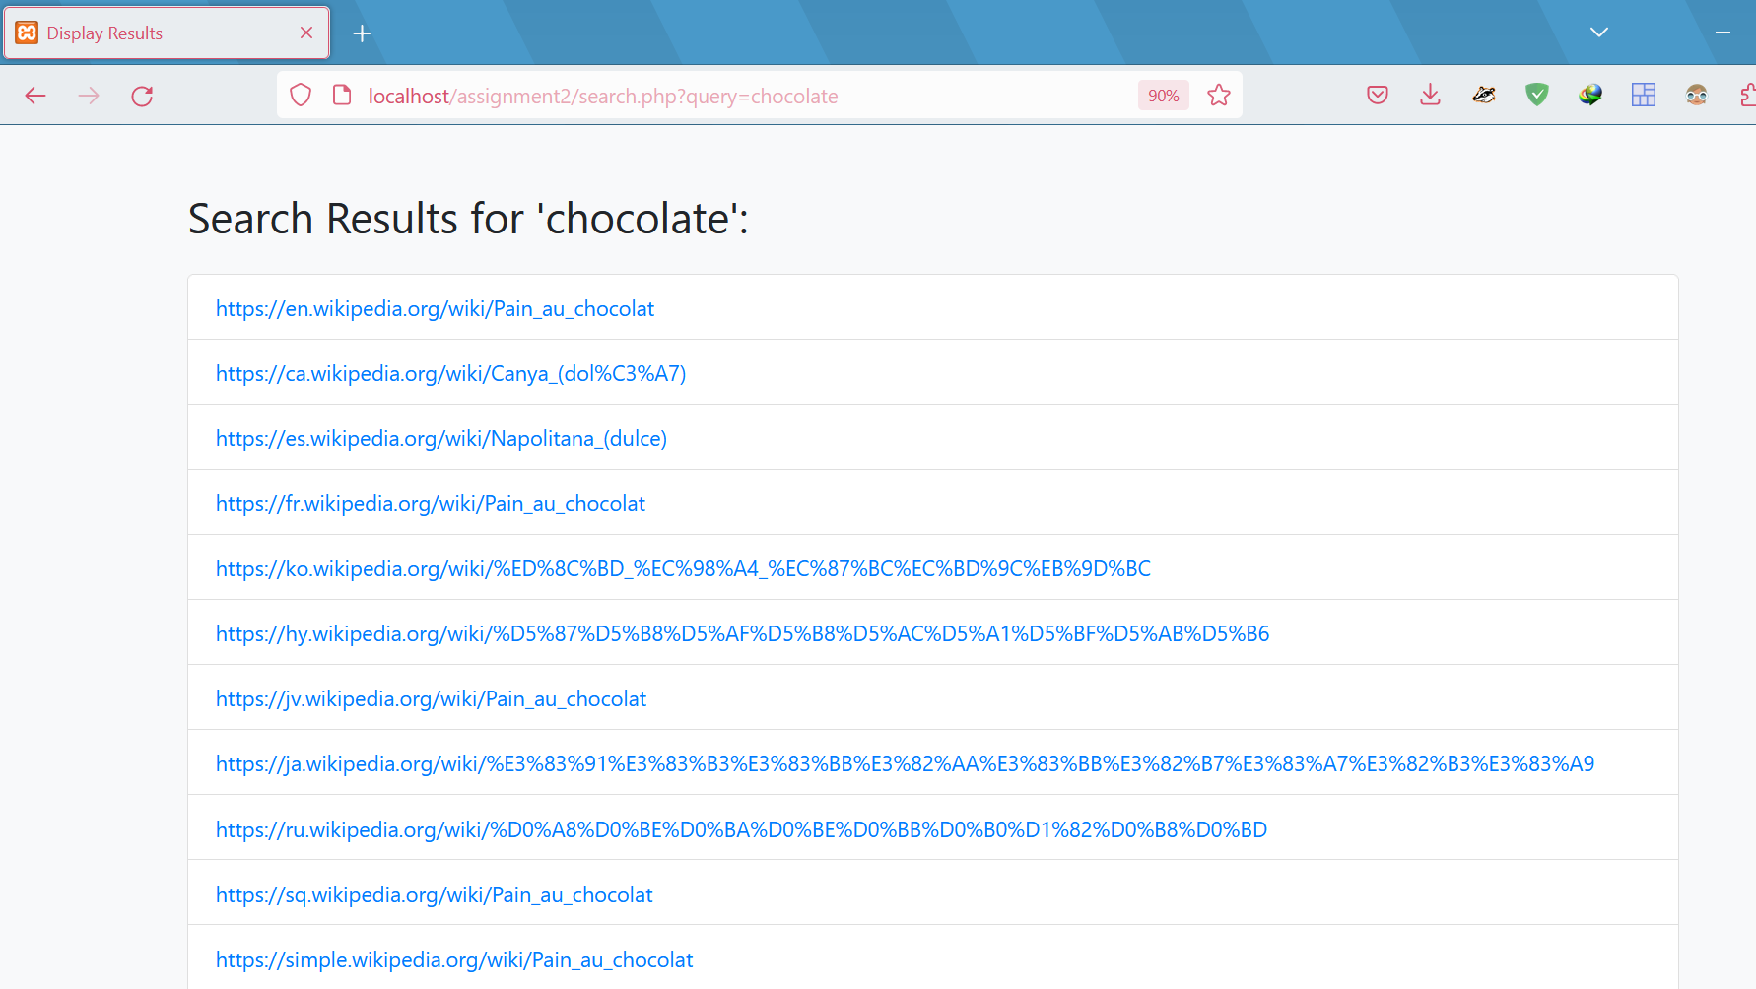

All u have to do is go to home.html and enter your desired string